Lab 1: Requirements Engineering & UML Use-Case Modelling

NAME : Dhanraj Rathod
Srn : PES1UG24AM359
Section : F

 | Type | Description | Priority | Acceptance Criteria | Rationale
FR-001 | Functional | The system shall track grant fund allocations, allow faculty to log equipment procurement expenses, and compute remaining budgetary balance. | High | Pass: Balance updates accurately and blocks expenses exceeding grant cap. Fail: Overdraft is allowed without admin override. | Required to monitor research grant funds and prevent overspending.
FR-002 | Functional | The system shall allow faculty researchers to record and update publication details, including indexing and citation information. | High | Pass: A faculty researcher can add a publication and its indexing and citation information is stored and displayed correctly. Fail: Publication or metric data is not saved correctly. | Required to track faculty publication metrics.
FR-003 | Functional | The system shall allow faculty researchers to submit publication records for co-author approval. | High | Pass: A submitted publication is made available to the required co-authors for approval. Fail: Co-authors cannot access the submitted record. | Required to support the co-author approval workflow.
FR-004 | Functional | The system shall allow the Research Dean to review and approve or reject submitted research grant expenses. | High | Pass: The Research Dean can approve or reject an expense and the decision is recorded. Fail: The decision is not recorded. | Provides oversight and control of research grant spending.
FR-005 | Functional | The system shall generate fund burn-up analytics showing grant allocation, expenditure, and remaining balance. | Medium | Pass: The system displays correct allocated, spent, and remaining amounts for a selected grant. Fail: Any displayed amount is incorrect. | Helps the Research Dean monitor fund utilization.
NFR-001 | Non-Functional | The system shall maintain an immutable, tamper-evident audit ledger for all financial approvals and journal status modifications. | High | Pass: Benchmarking and security tests confirm the required audit integrity, target latency, and security standards under simulated peak load. Fail: Audit records can be altered or security/latency targets are not met. | Protects financial records and provides accountability.
NFR-002 | Non-Functional | The system shall restrict grant and publication information to authorized users based on their roles. | High | Pass: Authorized users can access permitted records and unauthorized users are denied access. Fail: An unauthorized user can access restricted information. | Protects sensitive research and financial information.

UML Use-Case Diagram – Faculty Research Grant & Publication Tracker

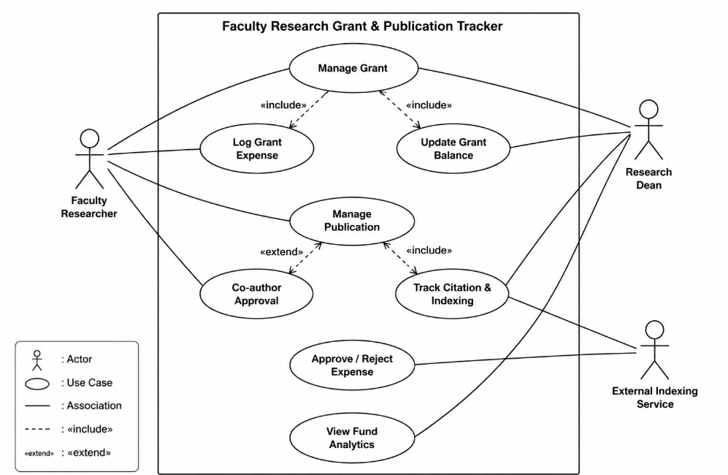

Use-Case Flow Specification
Use Case: Log Grant Expense
1. Preconditions
- The Faculty Researcher is logged into the system.
- A valid research grant exists.
- The Faculty Researcher has permission to record expenses.
- The grant has an available budget.
2. Main Success Scenario
- Faculty Researcher selects a research grant.
- Faculty Researcher selects "Log Grant Expense."
- The system displays the expense entry form.
- Faculty Researcher enters the expense amount and description.
- The system validates the expense details.
- The system records the expense.
- The system updates the remaining grant balance.
- The system submits the expense for Research Dean approval.
- Research Dean reviews the submitted expense.
- Research Dean approves the expense.
- The system records the approval and displays the updated grant balance.
- The use case ends successfully.
3. Alternate Flow — Expense Exceeds Grant Balance
- The system detects that the expense exceeds the available grant balance.
- The system rejects the expense.
- The system displays an error message.
- The Faculty Researcher is asked to enter a valid expense amount.
- The process continues from Step 4 of the main scenario.
- Postconditions

- The expense is recorded in the system.
- The grant balance is updated.
- The approval decision is recorded.
- The financial activity is available for audit and monitoring.

